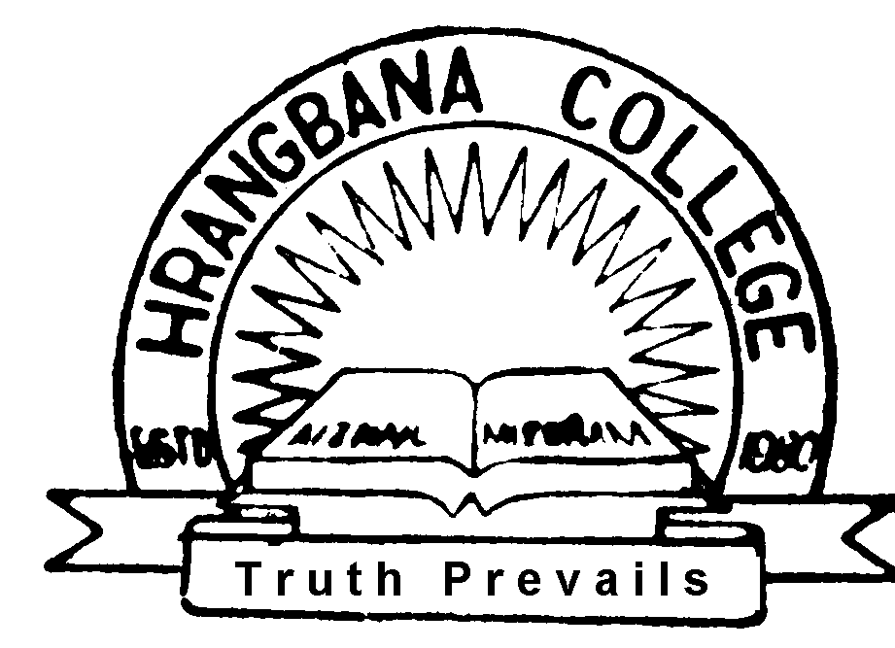
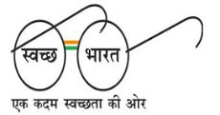
GOVT. HRANGBANA COLLEGE
AIZAWL - 796007 Phone : 2306540/2342953
MIZORAM Fax : (0389)2340984
Website-ghbc.edu.in Mail – hrangbanacollege2014@gmail.com, principal@ghbc.edu.in

Dated Aizawl, the 16th January, 2019

OFFICE ORDER
(Cleanliness Drive)

It is hereby notified to all concerned that Cleanliness Drive will be organised by NSS Unit and Cleanliness & Beautification Cell, Govt. Hrangbana College on 18th January, 2019 12:45 p.m. In this connection, all students are informed to assemble at the Golden Hall 1t 12:45 p.m. on 18th January, 2019.

Sd/- LALHMINGTHANGA
Principal

Copy to : All Head of Department - for favour of information.

(LALHMINGTHANGA)
Principal
Govt. Hrangbana College
Aizawl, Mizoram

****

