Department Seminar, 2026
Department of Economics

The Department of Economics, Govt Hrangbana College in collaboration with Research, Development and Project Committee, Govt Hrangbana College organized Annual department Seminar on 18th September, 2026 at the Golden Hall. The theme of the Seminar was “Exploring Contemporary Economic Issues-From Basic Economic principles to India’s Development”.
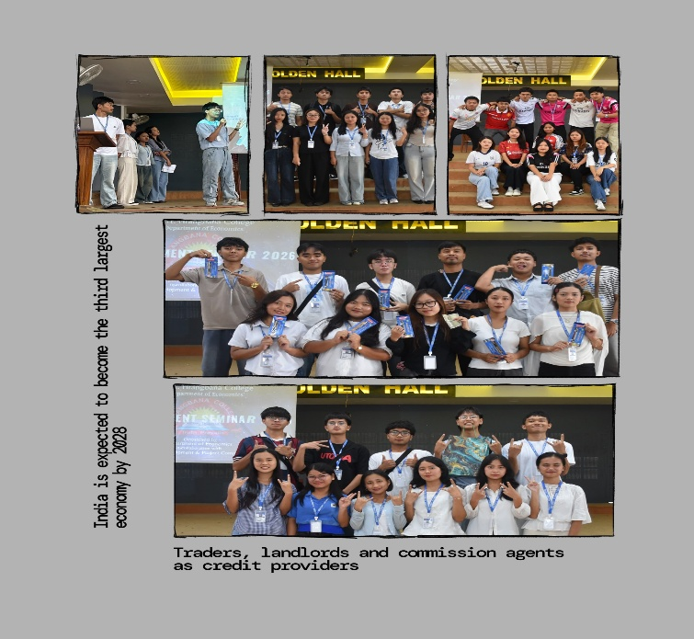
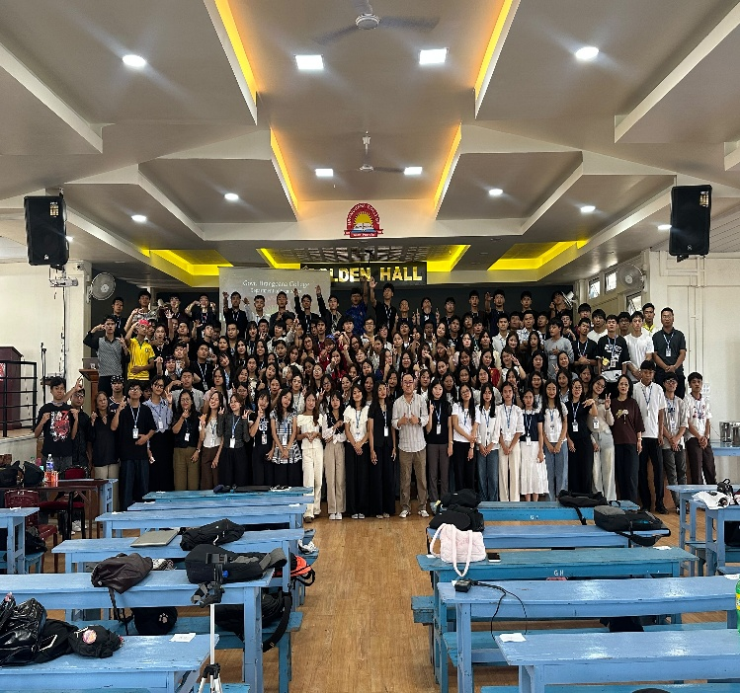
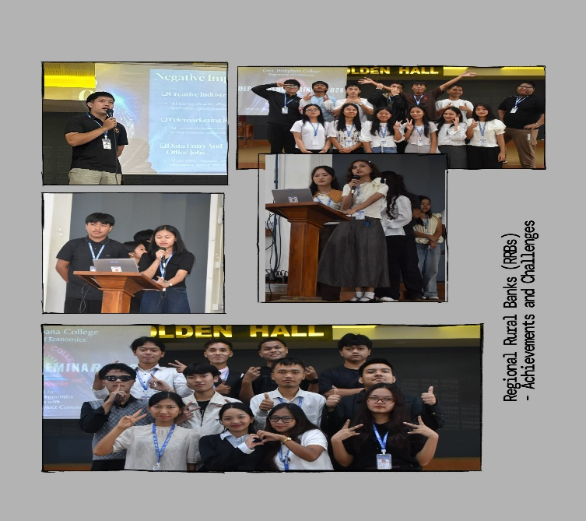
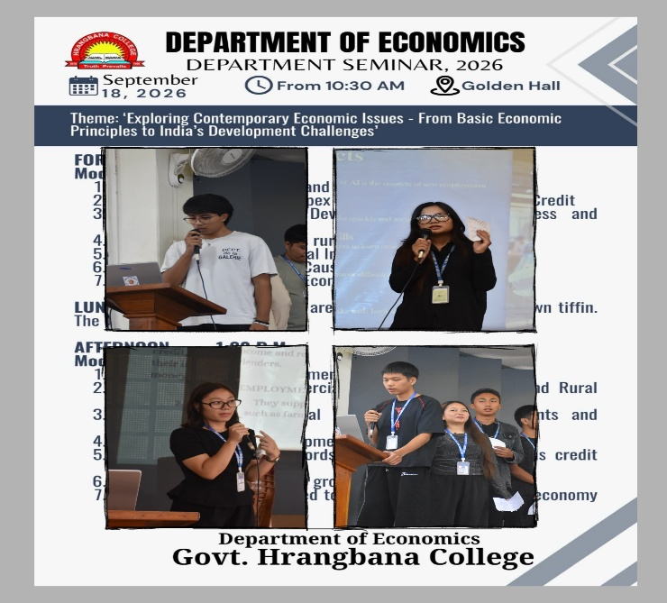

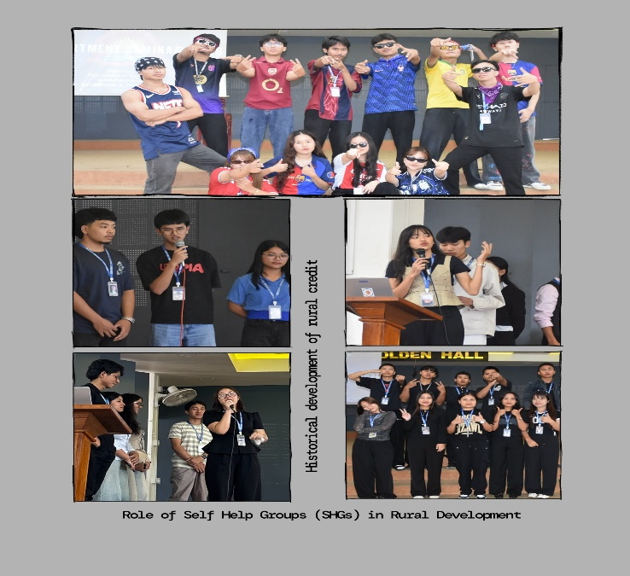
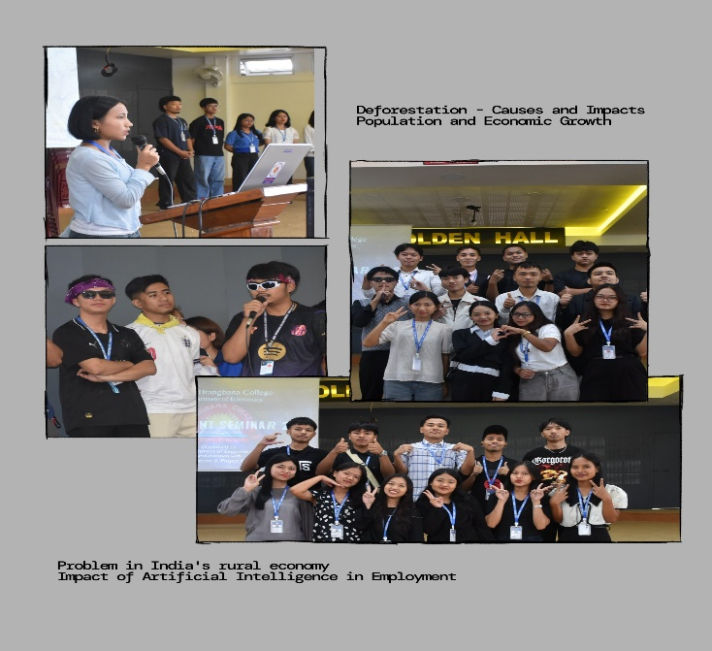

The students were divided into 14 groups and each groups presented a paper on various economic topics. After each presentation, questions were raised by students and answered by the presenting groups. the seminar was very successful as it helped students improved their presentation skills and conceptual understanding of various economic issues. All the students and faculty members of the department actively participated and made the Programme a grand success.

Dr C. Lalthantluangi
DIO, Dept of Economics

