REPORT ON PTM

MIZO DEPARTMENT ORGANIZED THE PARENT-TEACHER MEET
On August 6, 2026 (Friday), the Mizo Department of Govt. Hrangbana College successfully organized a Parent-Teacher Meet. The program was systematically divided into two sessions to facilitate targeted interactions with the parents and guardians of students from different semesters.
First Session: First Semester Students (10:30 AM)
The morning session, dedicated to the parents and guardians of First Semester students, commenced at 10:30 AM. The program was chaired by Mr. Rohmingthanga Ralte. Ms. H. Lalthanpuii, Associate Professor and Head of the Department, delivered the welcome address.
Following the introductory remarks, Mr. V. Lalberkhawpuimawia, Assistant Professor, delivered a comprehensive presentation detailing the college's academic administration and highlighting essential academic information for parents. This was succeeded by an interactive Question and Answer (Q&A) session. Furthermore, the session included a practical demonstration on the usage of the college's 'ERP' application. Parents were trained on how to effectively utilize this digital tool to monitor and support their children's academic progress.
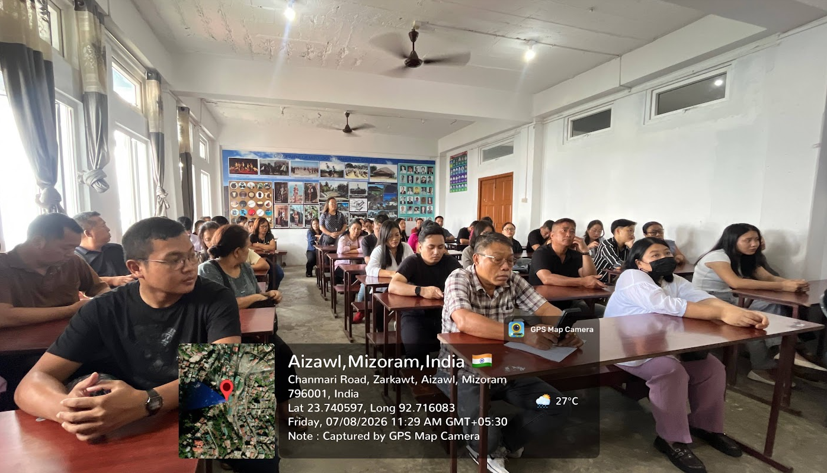
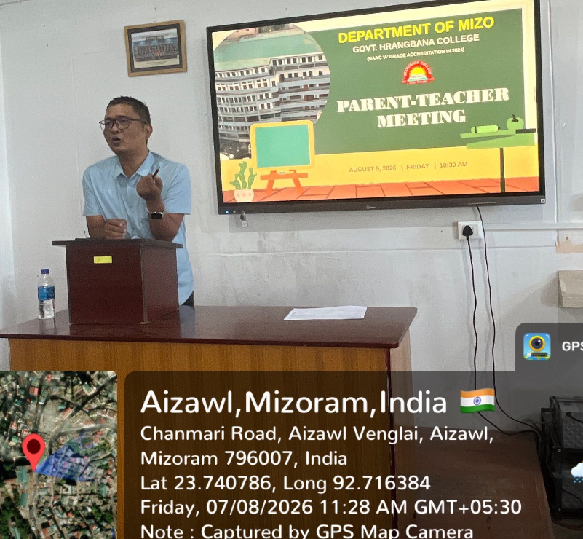 | 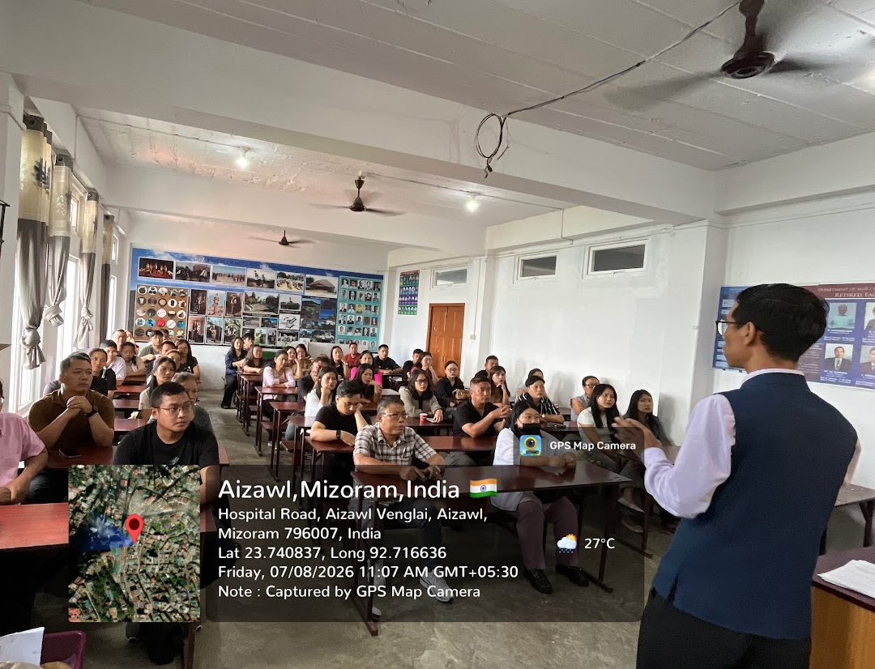

Second Session: Fifth Semester Students (12:30 PM)
The afternoon session commenced at 12:30 PM, focusing on the parents and guardians of Fifth Semester students. Chaired by Mr. Johny Lalremruata Pachuau, Assistant Professor, the session mirrored the structure of the morning program. It began with a welcome address by the Head of the Department, followed by a presentation by Mr. V. Lalberkhawpuimawia.
A significant portion of this session was dedicated to a comprehensive academic result review. Detailed and constructive discussions were held between the faculty and parents regarding the students' academic performances, specifically addressing areas requiring further effort and strategizing methods for academic improvement.
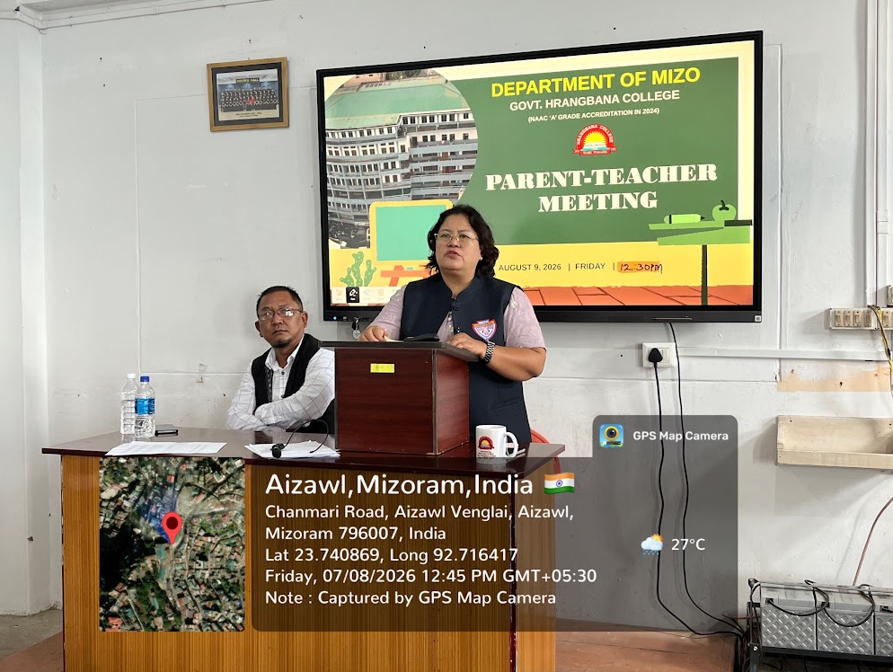 | 