Mizo Department of Govt. Hrangbana College and Govt. Johnson College Sign MoU for Academic Collaboration

On August 19, 2026, the Department of Mizo at Govt. Hrangbana College and Govt. Johnson College signed a Memorandum of Understanding (MoU) at the Govt. Johnson College Principal's Room to foster academic collaboration.
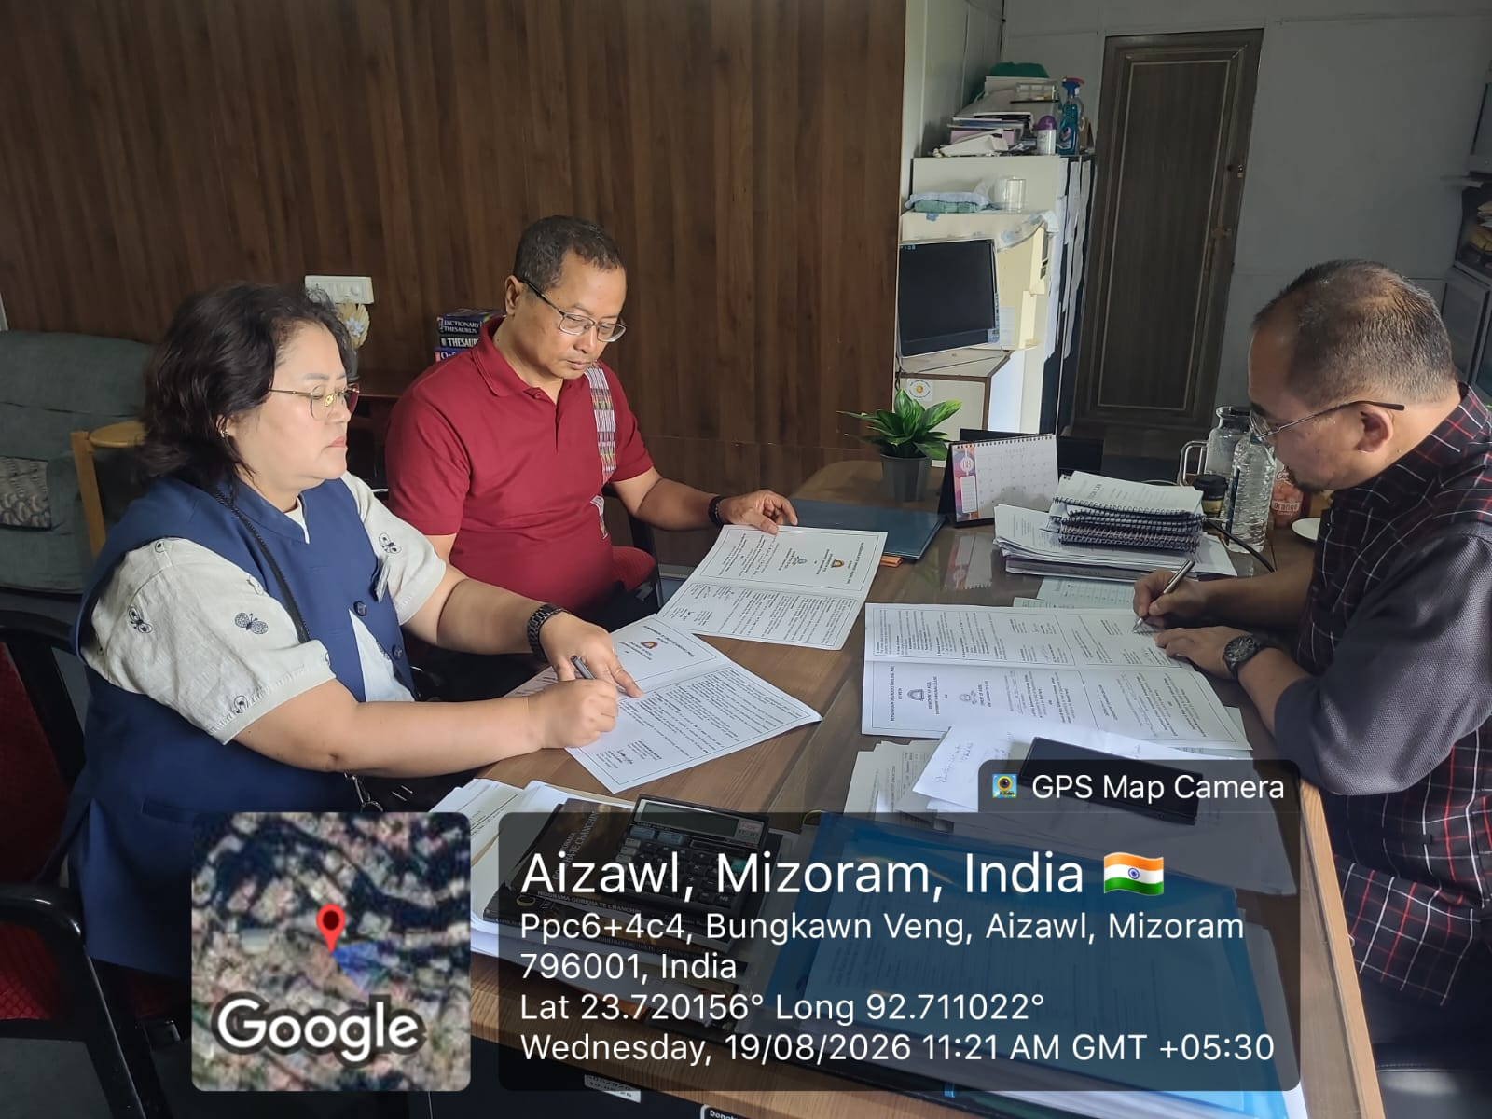

The agreement was signed by Principal Lalthlengliana Hrahsel and H. Lalthanpuii, Associate Professor & Head of the Mizo Department, on behalf of Govt. Hrangbana College, and by Principal Vanlalsawma and Lalrammawia Ngente, Head of the Mizo Department, representing Govt. Johnson College.

Valid for one year, the MoU encompasses faculty exchange programs and various academic cooperative initiatives. Following the signing ceremony, Govt. Hrangbana College Mizo Department faculty members V. Lalberkhawpuimawia and Johny Lalremruata Pachuau immediately conducted classes for the students of Johnson College in accordance with the agreement.
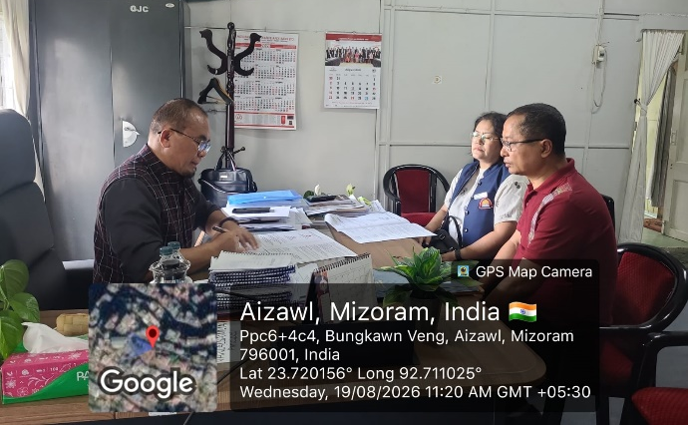 | 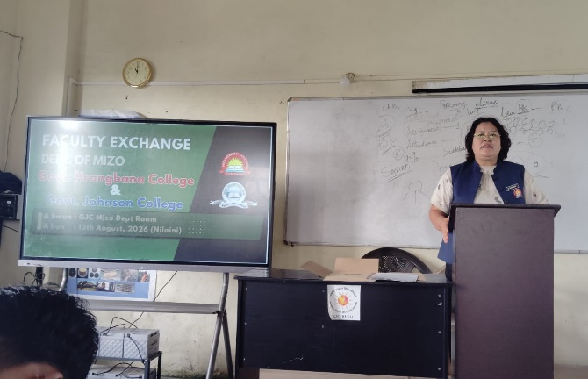
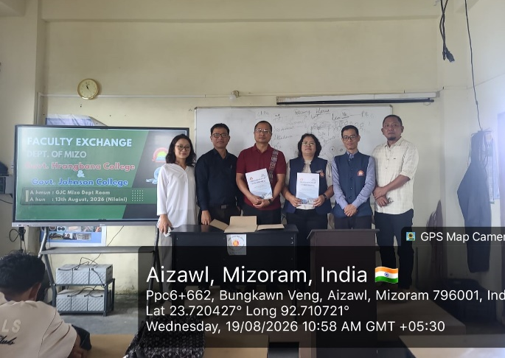 | 