ORIENTATION PROGRAMME
FIRST SEMESTER
DEPARTMENT OF GEOGRAPHY
GEVERNMENT HRANGBANA COLLEGE
DATE: 10.7.2026 Time: 10 am Place: Geography Core Room (Room No. 603)
CHAIRMAN: Dr. Lalramnunmawii
SPEAKER: Mr. C Lalhumbika
Faculty Present: Mr. B. Lalrawngbawla
Dr. Lalmalsawma Ralte
Ms. F. Vanlalhmangaihsangi
Mr. Lalruatfela
Number of Students: 56
Number of Present: 49
Number of Absent: 7
The main objective of the programme is to familiarize students with the following:
- The academic procedures for undergraduate (UG) courses.
- The institution's website, Moodle, and Hereus platforms.
- The infrastructure and facilities available to students.
- General information about the various academic, co-curricular, and extracurricular activities of the college.

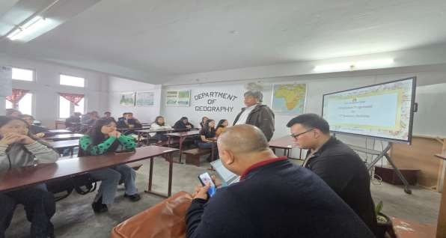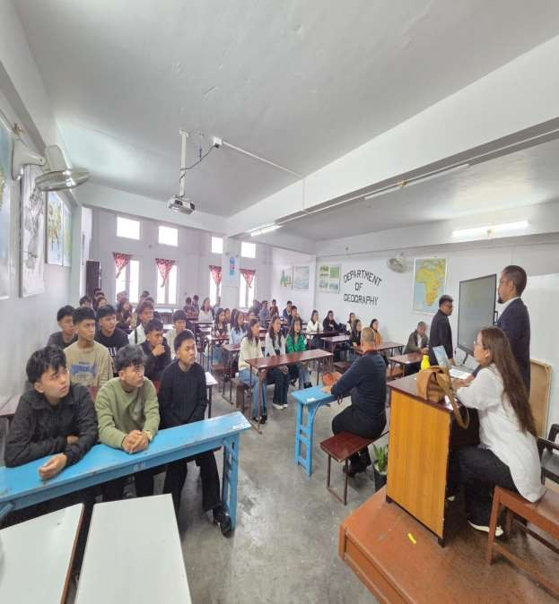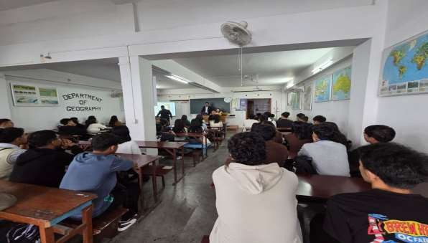

The programme was conducted successfully with active participation from the newly admitted students. It effectively familiarized students with the academic system, institutional facilities, and various support services available on campus. The sessions on the academic process, the institution's website, Moodle, and Hereus enabled students to better understand the digital platforms used for teaching and learning.
Students also gained valuable information about the college infrastructure, academic resources, and the wide range of co-curricular and extracurricular activities offered by the institution. The interactive nature of the programme encouraged students to ask questions and clarify their doubts, helping them feel more confident and prepared for college life.
Overall, the programme achieved its objectives by providing a smooth transition for students into the academic environment and creating awareness of the opportunities and resources available to support their personal and academic development.
